**Opensource Cypress Jsonnet Plugin**

**What is jsonnet?**

[Jsonnet](https://jsonnet.org/)  is a configuration language for application and tool developers. Developed by Google, few of the core principle and benefits.

|  |  |
| --- | --- |
| * Generate config data. | * Side-effect free, hermetic. |
| * Organize, simplify, unify. | * Manage sprawling config. |

**A simple extension of JSON**

|  |  |
| --- | --- |
| * Open source (Apache 2.0) * Familiar syntax * Reformatter, linter | * Editor & IDE integrations * Formally specified. * Used by many companies |

**Using Jsonnet with Cypress for dynamic test scenarios and payload:**

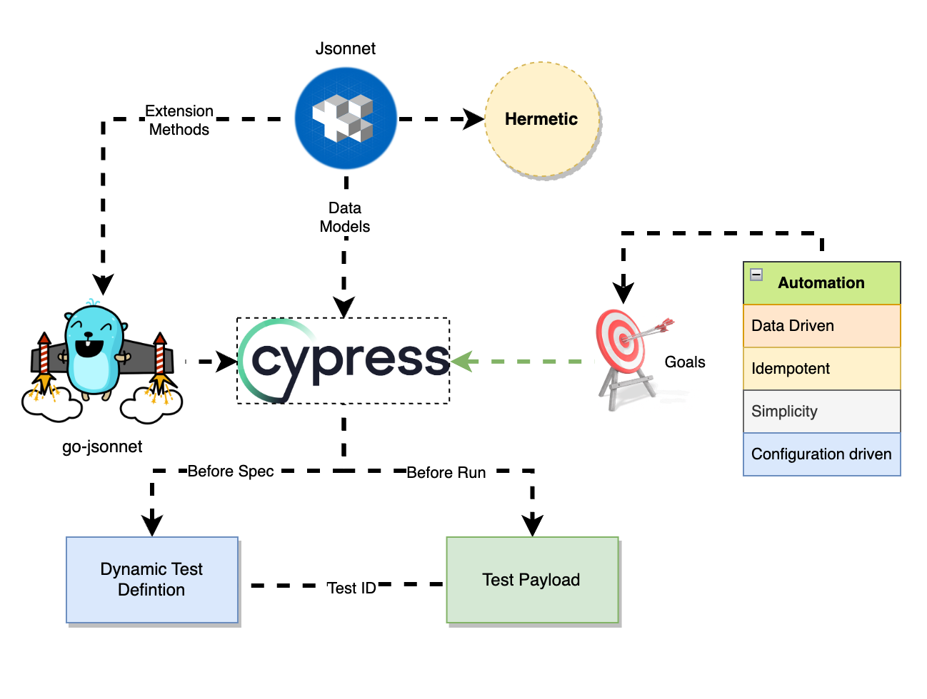

Things we could contribute to open-source community:

* Generate the jsonnet-cypress plugin code “cy-jsonnet-plugin” to public NPM repository.
* Add readme and examples on how this plugin will be used.
* Collaborate with Cypress to add this plugin on their web site.

The idea is to extend Cypress framework to work with Jsonnet. This will help any project with following benefits.

1. Eliminate duplication with object-orientation. Share and extend the models according to test case needs for code reuse and maintainability.
2. Efficient test data management with jsonnet based test data definition and generation.
3. Dynamic test data generation
4. Data randomization using custom native methods.
5. Extensible and model driven test cases- Balance the logic between test data / test definition (jsonnet) and high-level test workflow (Cypress specs) for creating model driven and extensible test cases for specific use cases.

**Cypress Jsonnet Plugin**

With the benefits we have observed in our usage of Jsonnet across many projects, we are proposing to make the cypress jsonnet code beneficial to not just us, but for the broader development community by creating a cypress jsonnet plugin for use by folks internal as well as external.

We have reviewed BD’s open-source software contribution guidance document. On the relevant sections copied below and highlighted, we are adhering to all guidelines. It will be great if you could consider the proposal and the team will be happy to help with next steps.

a. OSSPs requiring contribution agreement or similar contract to commit changes.

- no contract agreement needed.

b. OSSPs related to BD Core Technology. i. Examples of BD Core Technology: control software for specific BD device; analytic software for BD device data; image processing software for lateral flow assays

- not related to BD Core Technology

ii. Examples of non-BD Core Technology: logging utilities; generic database software drivers; general purpose user-interface framework.

- this is non-BD core technology as related to automation and software testing

c. OSSPs specifically designed for:

i. handling personally identifiable information; - not handling personally identifiable information

ii. handling protected health information; - not handling protected health information.

iii. diagnostics or other regulated software functions; or – not regulated and not related to diagnostics

iv. security. – not related to security

d. OSSPs not used or under consideration for use in a BD product or service. – used in BD for testing product.

e. OSSPs licensed under any license including in the “Use Not Recommended” category of the current BD Open-Source Usage Guidelines. - NA

f. OSSPs owned, sponsored, or controlled by a BD competitor. – not a BD competitor

g. Contributions designated for IP protection by BD. - NA

h. Projects hosted on a platform other than: i. GitHub – hosted in GitHub

ii. GitLab

i. Projects that would not comply with the BD Code of Conduct. - NA

j. Projects that are not actively maintained. One example of an actively maintained project is a project that has been updated by someone other than a BD associate within the last year. -NA